Alex Newcomb
CS 538
4/25/2026
Final Project Report

AI Disclosure
I used GPT-5.3 Codex to help me understand the mathematics within the ML-KEM functions and implement the low-level mathematical functions and operations. Otherwise, this project would have been extremely challenging to accomplish in an approximately 1-month timeframe. For understanding the mathematical algorithms, such as CBD sampling, the public key cryptography scheme, and the internal ML-KEM algorithms, I prompted the model with the NIST documentation and asked it to “clearly explain the algorithm for [algorithm] within the attached ML-KEM documentation. Explain to someone new to the ML-KEM encryption scheme and post-quantum cryptography.” I used a similar prompt for minor code generation. I provided the model with my outline for what my function should do, as well as my own defined class structure and the NIST documentation, and asked it to generate python code that met my specification. I then spent time visually analyzing the code and testing the code to ensure I understood exactly what it did.

Objective & Scope:
The goal of my project was to develop a toy implementation for the ML-KEM algorithm [1]. ML-KEM is a post-quantum cryptography algorithm for key encapsulation. Key encapsulation is a mechanism for sharing a secret key that can then be used for symmetric key encryption. The ML-KEM relies on a public key encapsulation mechanism. In ML-KEM (and key encapsulation methods broadly) Alice, who wants to send the secret key to Bob, generates both an encapsulation and decapsulation key. She keeps the decapsulation key private and sends the public encapsulation key to Bob. Bob then uses this encapsulation key to generate a shared copy of the secret key, K, as well as a ciphertext. He sends the ciphertext to Alice, who then uses the private decapsulation key and ciphertext to calculate the secret key, K’. If K and K’ match, then the process succeeded. If they do not match, the algorithm sends a pseudorandom key to Bob. This way, a malicious user eavesdropping cannot tell if the algorithm succeeded or not and therefore does not gain any useful information from the output of the algorithm [1]. ML-KEM is specifically based on the difficulty of the Module Learning with Errors problem, which involves solving systems of noisy linear equations in order to determine the secret key value.

In my implementation, I kept the core functionality of ML-KEM the same as the algorithm described in the official NIST report [1]. The key differences between my implementation and the real algorithm are as follows:
- Toy parameter set. I decided to experiment with four toy parameter sets and the real parameters for ML-KEM-512 in order to see how decapsulation failure decreases with time. I also wanted to try to understand the algorithm with small numbers before applying the large parameters found in the main algorithm.
- I did not use a Number-Theoretic Transform (NTT) for multiplication or for sampling (SampleNTT in the NIST documentation). For multiplication, I directly multiply the coefficients in the polynomials instead and perform multiplication inside the Ring specified by the documentation (R_{q}​= ℤ_{q}​[X]/(X^{n}+1)). For sampling, I uniformly sample coefficients for the polynomials. This simplified the mathematics to align more with the limited scope of a short-term project.
- I performed operations over the python structured directly, rather than on byte strings. This simplifies the code and made it clearer to me which components of the data are used for which operations. For example, when returning the decapsulation key, rather than returning a byte string, I return a struct containing the components of the decapsulation key: dk_kpke (decryption key from the public key scheme), ek (public key from the public key scheme), hash of ek, and z (secret fallback value used during decapsulation).
- I did not focus on computational efficiency or on retaining the computational efficiency of the algorithm.

Aside from these differences, I made my implementation as faithful to the original document as I could to maximize my understanding of the ML-KEM algorithm and to provide interesting results in the experiments.

Methods
My code consists of seven classes: encoding.py, kpke.py, mlkem.py, params.py, poly.py, sampling.py, and test_mlkem.py. The core of the logic exists in mlkem.py and kpke.py. Test_mlkem.py is the testing class used for the experiments. Params.py stores the global parameters, which can be changed by the user. This is where the different parameter sets can be set. All other classes provide mathematical utilities or helper functions. The parameter sets used for the experiments are shown in Table 1. Here, n is the polynomial degree, which determines how many coefficients each polynomial has and therefore the vector lengths. Parameter q (a prime value) provides the modulus used for all ring arithmetic, so every coefficient is reduced modulo q. Parameter k provides the module dimension, which is the size of vectors and matrices of polynomials. Variable η1 and η2 are noise control variables for sampling larger and smaller samples respectively. They are used during keygen and encryption. Lastly, du/dv are the bit widths used to compress coefficients in the ciphertext component.

Table 1. Parameter set sizes and values.
Set | n | q | k | η1​ | η2 | du | dv
A – Very Small | 16 | 97 | 2 | 2 | 2 | 4 | 4
B - Medium | 32 | 257 | 2 | 2 | 2 | 5 | 5
C - Large | 64 | 769 | 2 | 2 | 2 | 6 | 6
D – Very Large | 128 | 3329 | 2 | 2 | 2 | 7 | 7
Real Params (ML-KEM-512) | 256 | 3329 | 2 | 3 | 2 | 10 | 4

The results of the experiments are as follows for 100 trials, which were averaged to obtain the values shown in the figures. Figure 1 displays the decapsulation success rate on the different parameter sizes. This shows that on larger parameter sizes, including on the real parameter set, the decapsulation rate was 100%! This means that the implementation was overall successful for the toy ML-KEM, and that the simplified mathematics still resulted in tangibly lower success rates for the small parameter sizes, but 100% on the large sizes. Figure 2 presents the average runtime per trial in seconds. This figure shows that the runtime noticeably increases with the parameter set size, with the real parameters resulting in the slowest performance.

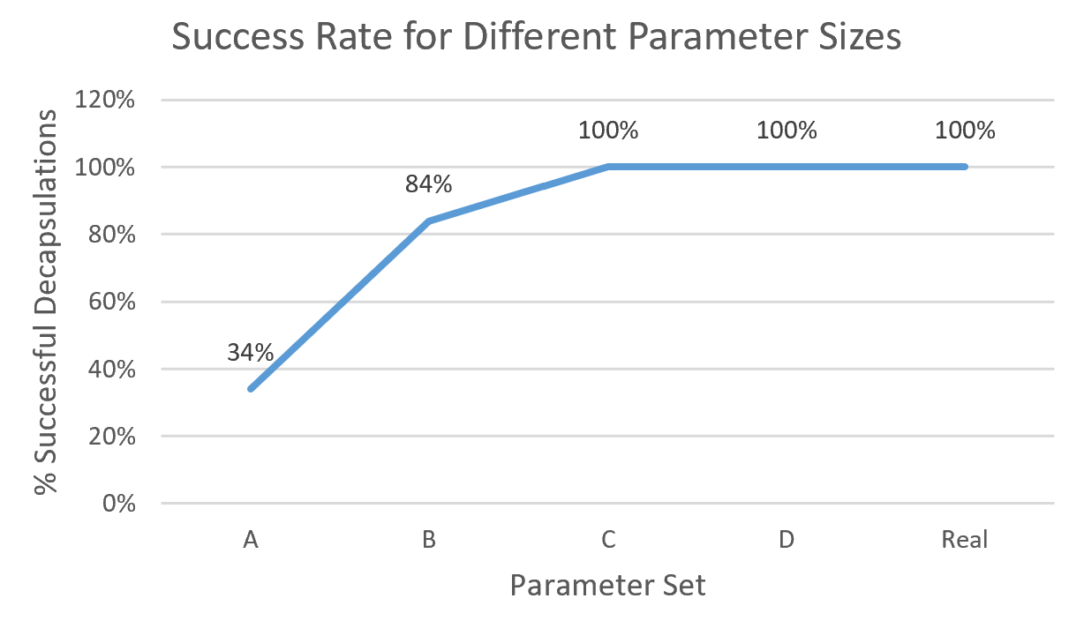
Figure 1. Decapsulation success rate results.

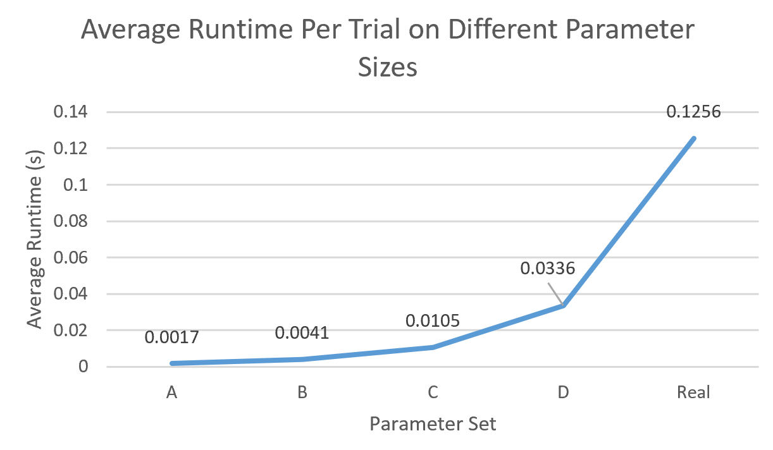
Figure 2. Average runtime per set.

The visualization summarizing the project is shown in Figure 3. When prompting GPT 5.3-Codex, I provided the source code and NIST documentation and asked it to “Generate an interesting visual conceptually summarizing the toy ML-KEM project.” The model generated a markdown file in the mermaid format that I then visualized using the Mermaid Live Editor.

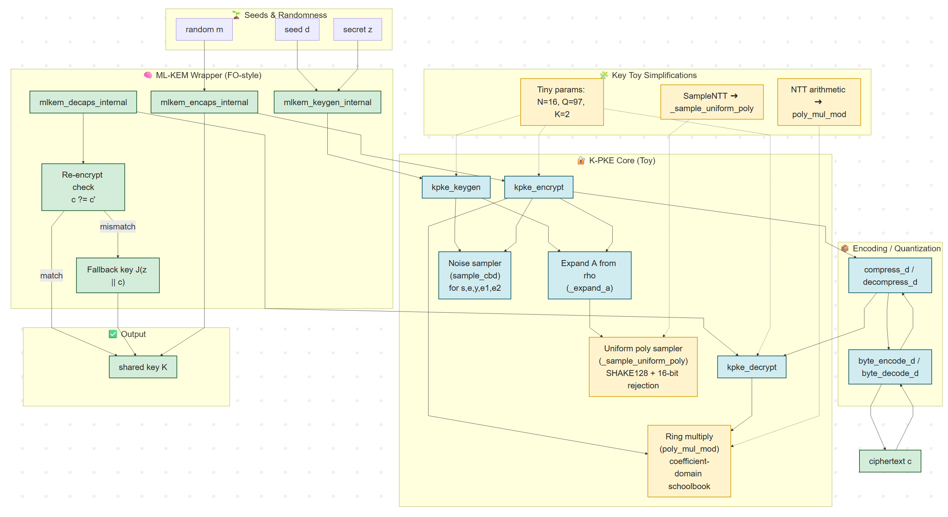
Figure 3. Mermaid live diagram conceptually visualizing the toy ML-KEM implementation.

References

[1] | National Institute of Standards and Technology, "Module-Lattice-Based Key-Encapsulation Mechanism Standard," Gaithersburg, MD 20899-8900, 2024.

